**Creation of Docker-compose.yml**

**1.What is Dockercompose?**

a. Docker Compose is a tool that makes it easier to create and run multi-container applications. It automates the process of managing several Docker containers simultaneously, such as a website frontend, API, and database service.

Docker Compose allows you to define your application’s containers as code inside a [YAML file](https://spacelift.io/blog/yaml) you can commit to your source repository. Once you’ve created your file (normally named docker-compose.yml), you can start all your containers (called “services”) with a single Compose command.

**Why use Dockercompose**

Most real-world applications have several services with dependency relationships—for example, your app may run in one container, but depend on a database server that’s deployed adjacently in another container. Moreover, services usually need to be configured with storage volumes, environment variables, port bindings, and other settings before they can be deployed.

## **Using Docker Compose**

### **Check if Docker Compose is installed**





### **Create a Docker Compose file**

Creating a docker-compose.yml file is the first step in using Compose. Copy the following content and save it to your own docker-compose.yml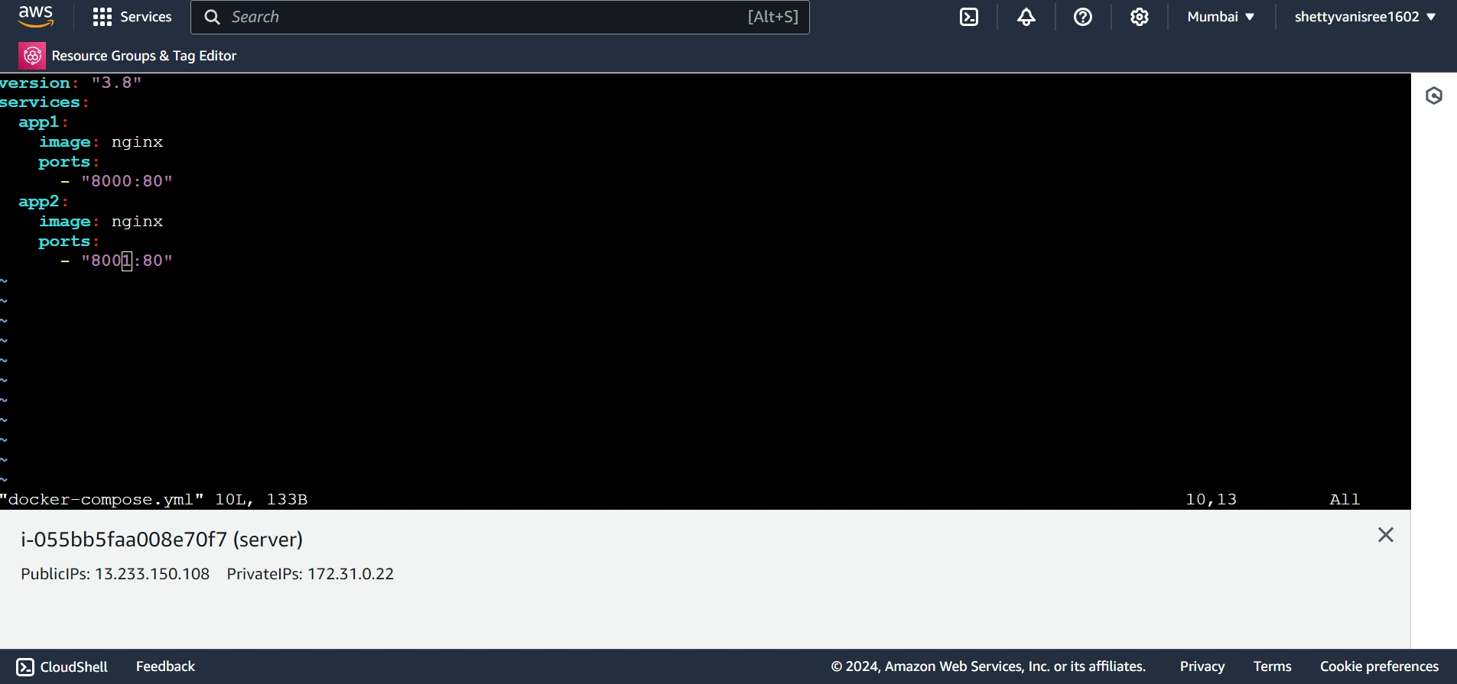

**Docker-compose installation:**

curl -SL https://github.com/docker/compose/releases/download/v2.30.3/docker-compose-linux-x86_64 -o /usr/local/bin/docker-compose

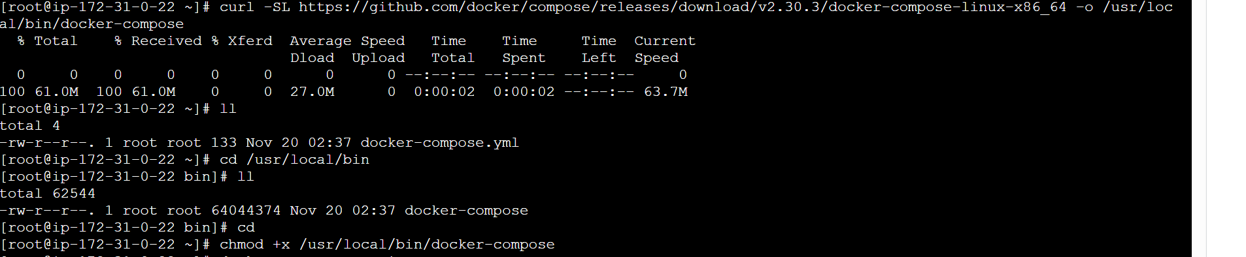

**Re-build Run the app with compose**

Docker-compose up –d to build and launch the app and start the file.

